Beaver Valley Ranch
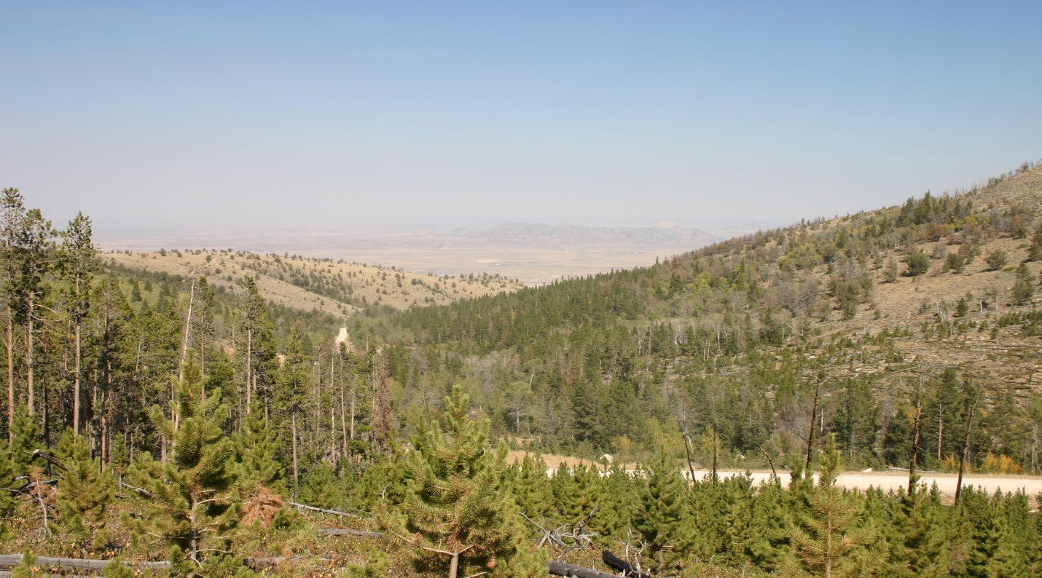

Presented by: Gary Lever
Broker / Owner

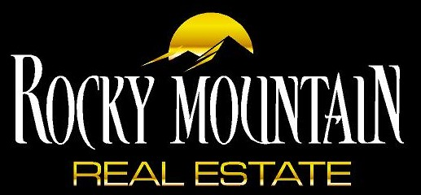
101 East 2nd Street, Casper WY 82601
307-473-9990 / 307-247-1032
gary@garylever.com

